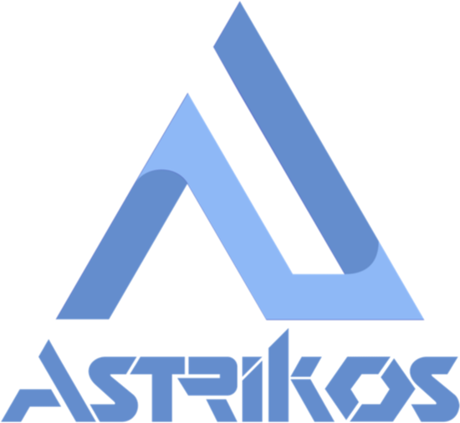
ASTRIKOS AI TECHNOLOGIES
S!aP — Smart Interop Analytical Platform
TECHNICAL PROPOSAL
Implementation of Asset Performance Management (APM) & Asset Investment Planning (AIP)
across The Tata Power Company Limited
In response to RFQ No.: 4100067197
Notice Inviting Expression of Interest (EOI) to Enter into an Outline Agreement of 6 Years
for Implementation of APM & AIP across Tata Power
Prepared for
The Tata Power Company Limited
Smart Centre of Procurement Excellence, Mumbai, Maharashtra
Submitted by
Astrikos AI Private Limited
India | USA | UAE | Singapore
pre-sales@astrikos.ai · www.astrikos.ai
Patented Technology · ISO/IEC 27001:2013 · ISO/IEC 21823-1:2019 · ISO 20001-1:2018

Document Number | Author | Date | Review | Sign Off
IND-UK-BUD-007-TECHPROP- 1.0 | Aashish G | 20/08/2026 | Ajit Hegde | Ajit Hegde

Document Control
Table of Contents
Contents
Document Control 2
Table of Contents 3
1. Executive Summary 5
1.1 Project Context 5
1.2 Project Objectives 5
1.3 Proposed Solution 6
1.4 Strategic Pillars 7
1.5 Project at a Glance 7
2. About the Proposed Solution & Platform Philosophy 8
2.1 Platform Overview 8
2.2 Solution Philosophy 8
2.3 Architecture Principles 9
3. Solution Architecture 10
3.1 Data Sources 10
3.2 Integration Layer — S!aP Connect 11
3.3 Data Platform — S!aP Datalake 11
3.4 Analytics & AI — S!aP ML & AI Central + AVEVA APM Engine 12
4. Project Understanding 13
4.1 Requirement Overview 13
4.2 Scope 13
4.3 Requirement-to-Solution Mapping 14
5. Key Use Cases & AI Enablement 15
6. Dashboards & User Experience 17
7. System Integration 19
7.1 Primary Integration — Grid Data Hub 19
7.2 Source-System Integrations 19
7.3 Integration Standards 20
7.4 Data Volumetric Profile 20
8. Cybersecurity & Data Governance 20
8.1 Security Architecture & Access Control 20
8.2 Data Protection 20
8.3 Monitoring & Compliance 21
8.4 Incident Response & Continuity 21
8.5 VAPT Requirements 21
8.6 Security & Compliance Deliverables 21
8.7 Data Governance Principles 21
9. Implementation Approach 22
10. Testing & Acceptance 23
10.1 Testing Stages 23
10.2 Acceptance Criteria 24
11. Training & Knowledge Transfer 24
11.1 Training Tracks 24
12. Deliverables 24
13. Assumptions, Dependencies, Client Responsibilities and Exclusions 25
13.1 Assumptions 25
13.2 Dependencies 25
13.3 Client Responsibilities 26
13.4 Exclusions 26
14. Key Differentiators / Why Astrikos 26

1. Executive Summary

1.1 Project Context
The Tata Power Company Limited (TPCL) has issued RFQ No. 4100067197 inviting Expression of Interest (EOI) for entering into a 6 (six) year Outline Agreement for the "Implementation of APM & AIP across Tata Power." The objective of the engagement is the design, supply, implementation, and Annual Maintenance Contract (AMC) of a Commercial-Off-The-Shelf (COTS) Asset Performance Management (APM) and Asset Investment Planning (AIP) software solution for TPCL's transmission and distribution (T&D) electrical assets, including power transformers, circuit breakers, switchgear, protection relays, cables, RMUs, and associated substation equipment.
TPCL has indicated that the proposed APM and AIP platform must operate as a centralized enterprise utility intelligence layer, integrating operational, maintenance, financial, planning, regulatory, GIS, SCADA, and customer-impact data into a unified analytical ecosystem. Central to this requirement is seamless integration with TPCL's indigenous, cloud-hosted Grid Data Hub (GDH), which aggregates data from TPCL's IT and OT landscape — including SAP ERP (MM, PM, PS, FICO), SAP ISU, SAP CRM, ADMS, GIS, Wrench, CYMEDIST, E-WATCH, PQM, BOLA, MDM, and NFMS — via APIs, FTP/SFTP, or messaging queues.
Astrikos AI Technologies has studied the RFQ, the detailed Scope of Work (Annexure VII), the technical specifications, the Service Level Agreement (SLA) framework, the data volumetric and field-device profile of TPCL's network, and the General Conditions of Contract, and has structured this technical proposal to directly and traceably respond to each stated requirement.

1.2 Project Objectives
Based on the RFQ, Astrikos understands TPCL's core objectives for this engagement to be the following:
- Transition TPCL from routine, time-based maintenance practices to a condition-driven, business-aligned Asset Performance Management approach that improves both reliability and financial performance of T&D electrical assets.
- Establish a unified Asset Health Index (AHI), Asset Criticality Index (ACI), and Asset Risk Index (ARI = Probability of Failure × Consequence of Failure/ACI) computed dynamically across all major asset classes (transformers, circuit breakers, switchgear, protection relays, cables, RMUs, and linear assets).
- Enable AI/ML-based predictive ageing, Remaining Useful Life (RUL) forecasting, Failure Modes, Effects & Criticality Analysis (FMECA), and Reliability-Centred Maintenance (RCM) aligned with ISO 55001, ISO 31000, and IEC 60300-3-11.
- Deliver an Asset Investment Planning (AIP) capability that converts asset condition, risk, and reliability data into data-driven, risk-aligned, and financially sustainable CAPEX/OPEX investment decisions, tariff and ARR impact modelling, and regulatory-ready investment justification packs.
- Integrate seamlessly with the TPCL Grid Data Hub (GDH) and downstream enterprise systems (SAP suite, ADMS, GIS, SCADA, CYME DIST, MDM) without displacing any existing IT/OT investment.
- Provide a SaaS-hosted, India-resident, cyber-secure platform with defined performance, availability, and support SLAs, delivered under a phased implementation, hypercare, and 60-month managed services model.

1.3 Proposed Solution
Astrikos proposes a two-layer solution architecture that is deliberately structured to satisfy the RFQ's COTS requirement while delivering the depth of AI/ML-driven intelligence that TPCL's APM and AIP use cases demand:
- Layer 1 — AVEVA Asset Performance Management: A Commercial-Off-The-Shelf industrial APM engine providing out-of-the-box asset templates (make/model libraries), condition-based monitoring, physics-informed degradation models, and reliability analytics (FMECA/RCM) for major electrical asset classes — transformers, circuit breakers, switchgear, protection relays, and linear assets.
- Layer 2 — Astrikos S!aP Operational Intelligence Overlay: S!aP (Smart Interop Analytical Platform) sits above the AVEVA APM engine and the TPCL Grid Data Hub, providing vendor-neutral integration (S!aP Connect), a unified operational data lake (S!aP Datalake), AI/ML-driven risk, criticality, and investment-planning intelligence (S!aP ML & AI Central), workflow and investment governance (S!aP BPM), role-based dashboards and reporting (S!aP Viz), and a conversational AI advisory layer (S!aP Agentic — S!a) that together deliver the Asset Investment Planning (AIP) capability the RFQ requires.
This combination allows Astrikos to meet the RFQ's COTS mandate through AVEVA's proven, standards-aligned APM engine, while the S!aP Glass Box AI/ML and BPM layer delivers the configurable, explainable, and financially oriented AIP intelligence, investment optimization, and regulatory reporting capability that a packaged APM product alone does not provide. Both layers are deployed on TPCL's Azure/AWS-hosted VNet, alongside the Grid Data Hub, with all data and processing resident within India as mandated.

1.4 Strategic Pillars
Strategic Pillar | What It Means for Tata Power
Single Accountable Partner | Astrikos owns end-to-end delivery — BRD discovery, COTS configuration, AI/ML model deployment, GDH integration, dashboarding, testing, hypercare, and 60-month managed services — as a single point of accountability under the Outline Agreement.
COTS + Configurable Intelligence | AVEVA APM satisfies the RFQ's COTS mandate for condition monitoring and reliability analytics; S!aP's Glass Box AI/ML and BPM layer delivers configurable Asset Investment Planning without bespoke, unauditable code.
Standards-Aligned Engineering | AHI/ACI/ARI computation, predictive ageing, and RCM are implemented in direct alignment with ISO 55001, ISO 31000, IEC 60300-3-11, IEC 62508, ISO 13374, ISO 17359, IEC 62506, ISO 14224, IEC CIM, and IEEE degradation modelling standards referenced in the RFQ.
Data Sovereignty & Glass Box Transparency | All data, models, and workflows are hosted within India on TPCL's VNet, remain TPCL-owned at all times, and are fully auditable and explainable to authorized TPCL administrators — no black-box AI logic.
Vendor-Neutral Integration | S!aP Connect ingests from the Grid Data Hub and, where required during design, directly from SAP, ADMS, GIS, SCADA, and CYME DIST via REST/RESTful APIs, ODBC, file-based, and messaging-queue mechanisms — without displacing any existing TPCL system.
Governed AI/ML & Explainability | Every AHI/ACI/ARI score, RUL prediction, and investment recommendation is traceable to its triggering data and model logic, satisfying the RFQ's explainability and auditability requirements for automated decision-making.

1.5 Project at a Glance
Parameter | Details
Client | The Tata Power Company Limited (TPCL)
RFQ Reference | 4100067197 — "Implementation of APM & AIP across Tata Power"
Contract Type | Outline Agreement, 6 years, milestone-based implementation + 60-month Managed Services/AMC
Scope | Design, supply, implementation, and 5-year AMC of COTS APM & AIP software for TPCL T&D electrical assets
Core Platform | AVEVA Asset Performance Management (COTS engine) + Astrikos S!aP Operational Intelligence Overlay (AI/ML, integration, BPM, visualization, agentic advisory)
Deployment Model | SaaS, cloud-hosted on the same VNet as TPCL's Grid Data Hub (GDH); all data and processing resident within India
Primary Integration | TPCL Grid Data Hub (GDH) via REST/RESTful APIs, ODBC, file-based ingestion (SFTP/FTP), and messaging queues; downstream sources include SAP MM/PM/PS/FICO/ISU/CRM, ADMS, GIS, Wrench, CYMEDIST, E-WATCH, PQM, BOLA, MDM, NFMS
Key Indices | Asset Health Index (AHI), Asset Criticality Index (ACI), Asset Risk Index (ARI = PoF × CoF/ACI)
Data Volume | ~20,000 GB initial load; ~15 GB/day incremental (per RFQ data volumetric table)
Network Scale (indicative) | 36 distribution substations, 1,120 consumer substations, 3,527 breakers, 10,223 isolators, 1,480 RMUs, 1,302 FPIs, 70 power transformers (DSS), 1,072 transformers (CSS), 490 FRTUs, 36 RTUs (per RFQ Section 3.7)
Implementation Milestones | M1 Blueprinting (1 month) → M2 APM UAT (3 months) → M3 AIP UAT (5 months) → M4 Hypercare (3 months post go-live) → M5 Managed Services & AMC (60 months)
Support Model | 8×6 L1/L2/L3 support with defined severity-based response/resolution SLAs, 99.5% monthly availability target, RPO ≤ 15 minutes, RTO ≤ 1 hour

2. About the Proposed Solution & Platform Philosophy

2.1 Platform Overview
Astrikos AI Technologies is a deep-technology company specializing in operational intelligence for complex, multi-system infrastructure environments, with offices across India, USA, UAE (MEA Regional HQ), and Singapore. The proposed solution for TPCL combines two complementary layers:
- AVEVA Asset Performance Management (APM): A globally deployed, Commercial-Off-The-Shelf industrial APM suite providing pre-built asset templates, condition monitoring, physics-based degradation modelling, and reliability engineering (FMECA/RCM) capability, satisfying the RFQ's COTS mandate at Clause 1 of the Notice Inviting Request for Information.
- S!aP (Smart Interop Analytical Platform): Astrikos' patented, vendor-agnostic, AI-native operational intelligence platform, which provides the Asset Investment Planning (AIP) intelligence, cross-system integration, AI/ML risk modelling, workflow governance, dashboards, and conversational advisory capability that extend the AVEVA APM engine into a complete, TPCL-specific APM + AIP solution.
S!aP operates as a vendor-neutral intelligence layer above existing operational systems — ingesting data from any IT, OT, or ET source (including TPCL's Grid Data Hub) and transforming it into contextual intelligence, governed action, and proactive advisory — without displacing TPCL's installed SAP, ADMS, GIS, SCADA, or CYME DIST investments. The operational intelligence lifecycle followed throughout this proposal is: S!aP — Connect · Collect · Historize · Analyze · Integrate · Visualize · Advise.

2.2 Solution Philosophy
The solution philosophy rests on Astrikos' Glass Box Architecture, which directly addresses the RFQ's repeated emphasis on explainability, auditability, and traceability of automated recommendations (Sections 3.2.4 "Decision Support" and 3.4.11 "AI/ML & Analytics Capability" of the Scope of Work):

Glass Box Principle | Application to TPCL APM/AIP
Transparency | Every AHI/ACI/ARI calculation, RUL prediction, and investment recommendation carries a visible, auditable rationale (e.g., decision-tree explainability) rather than an opaque model score.
Configurability | TPCL-authorized administrators can adjust health-scoring weights, risk thresholds, RCM intervals, and investment-optimization constraints without vendor code changes, consistent with the RFQ's requirement for configurable risk models and thresholds.
Sovereignty | All AHI/ACI/ARI models, investment logic, and historical data reside within TPCL-controlled, India-hosted infrastructure on the same VNet as the Grid Data Hub; TPCL retains full and exclusive ownership of all data at all times, including on contract expiry or termination.
Vendor Independence | S!aP Connect integrates with SAP, ADMS, GIS, SCADA, CYME DIST, and the Grid Data Hub through open protocols (REST/RESTful APIs, ODBC, file-based, messaging queues), so TPCL is never locked into a single OEM data model.

2.3 Architecture Principles
- COTS-first, configuration-over-customization: AVEVA APM's out-of-the-box asset-type library (transformers, circuit breakers, switchgears, isolators, protection relays, batteries, linear assets) and S!aP's configurable rule/model engine are used to meet requirements through configuration wherever possible, with bespoke development reserved for TPCL-specific business rules identified during the Blueprinting phase.
- API-first integration: All data exchange with the Grid Data Hub and downstream TPCL systems uses documented REST/RESTful APIs, ODBC, SFTP/FTP file-based ingestion, or messaging queues, with a published API catalogue, endpoint documentation, and versioning as required under the RFQ's Documentation Requirements (Section 6).
- Layered, defence-in-depth security: Network segmentation, least-privilege access, RBAC/ABAC integrated with TPCL's central directory and MFA, encryption at rest and in transit, and SIEM integration are designed in from the outset rather than retrofitted.
- Scalable, cloud-native deployment: Auto-scaling, load-balancing, and failover mechanisms are built into the hosting architecture to accommodate TPCL's stated data volumes (~20,000 GB initial, ~15 GB/day incremental) and future expansion of assets, sensors, and data sources.
- Standards-aligned analytics: Asset health, risk, and reliability models are built to align with ISO 55001 (Asset Management), ISO 31000 (Risk Management), IEC 60300-3-11 (RCM), IEC 62508 (Dependability Engineering), ISO 13374/ISO 17359/IEC 62506 (Condition Monitoring), ISO 14224 (Reliability & Maintenance Data), and IEC CIM (lifecycle data representation).

3. Solution Architecture
This section presents the layered solution architecture proposed for TPCL, organized by the functional layers through which data moves from source systems to actionable, visualized intelligence.
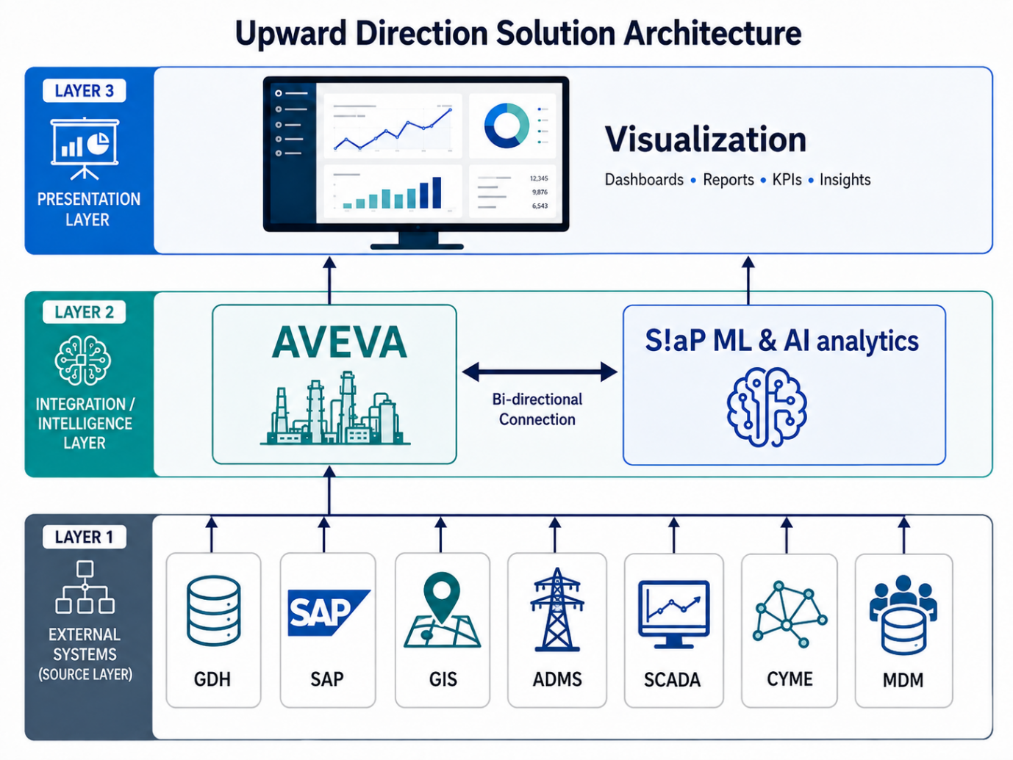

3.1 Data Sources
The proposed platform is designed to ingest data from TPCL's Grid Data Hub (GDH) as the primary and indigenous data source, supplemented — where agreed during the Blueprinting phase — by direct connections to underlying business systems named in the RFQ:
Source System | Data Domain | Ingestion Mechanism (per RFQ)
Grid Data Hub (GDH) | Unified historical & real-time analogue/digital asset data | REST/RESTful APIs, ODBC, file-based ingestion, messaging queues
SAP ERP — Material Management (MM) | Spares, inventory, procurement | Flat Files / CSV (per RFQ data volumetric table)
SAP Plant Maintenance (PM) | Maintenance history, work orders | Via GDH
SAP Project System (PS) | Capital project tracking | Via GDH
SAP FICO | Financial, CAPEX/OPEX, budget data | Via GDH
SAP ISU (Customer Billing) | Customer-impact & billing data | Flat Files / CSV
SAP CRM | Customer relationship data | Via GDH
ADMS (Schneider) | Network operations, switching state | MS SQL
GIS | Asset location & network topology | Flat Files / CSV
OSI SCADA | Real-time operational telemetry | Mongo DB & Cassandra
Wrench | Project management | Via GDH
CYMEDIST | Load-flow / network planning analysis | Via GDH (for AIP resource-allocation use cases)
E-WATCH, PQM, BOLA, NFMS | Power quality, outage/bill exception, network fault management | Via GDH
MDM (Meter Data Management) | Meter reads and events | Flat Files / CSV
Per RFQ Section 3.7, the initial data load across these sources is approximately 20,000 GB, with an incremental load of approximately 15 GB/day. The exact list of source systems requiring direct (non-GDH) connectivity, and the corresponding field mappings, will be confirmed and documented in the Business Requirement Document (BRD) during the Blueprinting milestone.

3.2 Integration Layer — S!aP Connect
S!aP Connect is the vendor-neutral ingestion and integration layer through which the platform consumes the Grid Data Hub's standardized exports and, where required, connects directly to source systems. It supports REST/RESTful APIs, ODBC, SFTP/FTP file-based ingestion, and messaging queues, and exposes a published API catalogue (endpoints, request/response schema, authentication mechanism, error codes, sample payloads, version history) as required under the RFQ's Documentation Requirements.
- Configurable data refresh rates supporting real-time, near-real-time, and batch ingestion, as required by RFQ Section 3.6.4 (Performance & Scalability).
- Schema validation and data-quality checks applied at ingestion to protect downstream analytics from malformed or incomplete GDH exports.
- Support for industry-standard data formats (XML, JSON, CSV) and protocols (REST, SOAP, ODBC) per RFQ Section 3.6.5 (Interoperability).
- Designed for high-volume ingestion from multiple IT/OT systems without performance degradation, and to scale with future expansion of assets, sensors, and data sources.

3.3 Data Platform — S!aP Datalake
The S!aP Datalake serves as the operational system of record for all ingested asset, maintenance, financial, and network data. It maintains a time-series and asset-hierarchy structured store that underpins AHI/ACI/ARI computation, RUL prediction, and AIP scenario modelling, and provides the auditable historical basis required for regulatory reporting and traceability.
- Asset hierarchy and pre-built asset type (make/model) library covering transformers, circuit breakers, switchgears, isolators/disconnectors, protection relays, batteries, and linear (line/cable) assets, as required under RFQ Section 3.2.1.
- Time-series storage for condition-monitoring parameters (temperature, vibration, load, partial discharge, oil quality, DGA) at configurable refresh intervals.
- A compliance-grade audit trail of all data changes, model outputs, and workflow actions, supporting the RFQ's data-retention, data-masking, and row/column-level security requirements.
- All data storage and processing hosted within India, on the same VNet as the Grid Data Hub, ensuring compliance with national data-sovereignty requirements; all data generated remains the exclusive property of TPCL at all times.

3.4 Analytics & AI — S!aP ML & AI Central + AVEVA APM Engine
The cognitive intelligence of the solution is delivered jointly by the AVEVA APM engine (condition-based monitoring, physics-informed degradation modelling, and out-of-the-box reliability libraries) and S!aP ML & AI Central (configurable risk/criticality scoring, machine-learning-based RUL forecasting, and AIP financial/optimization models). Together they compute:
- Asset Health Index (AHI): Dynamically computed using configurable, explainable scoring models incorporating asset age, operational loading, environmental exposure, maintenance records, diagnostic tests, inspection findings, DGA analysis, vibration, oil quality, thermal stress, partial discharge, and outage history.
- Asset Criticality Index (ACI): Computed from asset importance, network dependency, customer impact, redundancy availability, load served, regulatory importance, and business continuity implications.
- Asset Risk Index (ARI): ARI = Probability of Failure (PoF) × Consequence of Failure (CoF/ACI), aligned with ISO 55001 and ISO 31000, computed per asset type using the risk parameters specified in RFQ Section 3.3.5 (e.g., failure rate, spare availability, financial loss degree, cost of failure, historical failure cost).
- Predictive Ageing & RUL: Machine-learning models trained on historical operational and maintenance data, incorporating IEEE physical degradation models, ISO 14224 Weibull reliability parameters, and IEC CIM lifecycle attributes.
- FMECA / RCM: Failure Modes, Effects & Criticality Analysis and Reliability-Centred Maintenance with configurable age thresholds and auto-generated maintenance tasks and intervals, aligned with IEC 60300-3-11.
All AI/ML models are governed under an explainability and auditability framework (decision-tree style rationale), with defined retraining, accuracy-benchmarking, and model-governance mechanisms, satisfying RFQ Section 3.4.11.

4. Project Understanding

4.1 Requirement Overview
TPCL requires a Design, Supply, Implementation, and Annual Maintenance Contract (AMC) of a COTS APM and AIP software solution for its transmission and distribution electrical assets. The RFQ frames this as a Digital Utility Transformation initiative: moving TPCL from manual, time-based asset management to a predictive, data-driven, and reliability-focused operational ecosystem, with the Grid Data Hub (GDH) as the indigenous data backbone.
Astrikos' understanding is that the successful bidder must deliver two distinct but integrated capabilities:
- Asset Performance Management (APM): Real-time and batch computation of Asset Health, Criticality, and Risk Indices; predictive ageing/RUL; FMECA/RCM-based reliability planning; and condition-based monitoring, across all major electrical asset classes.
- Asset Investment Planning (AIP): Value-framework-driven investment prioritization, CAPEX/OPEX optimization, asset lifecycle planning (5–10 year horizon), scenario modelling, tariff/ARR impact analysis, and regulatory-ready investment justification, integrated with TPCL's finance systems (via GDH) and network planning tools (CYME DIST).

4.2 Scope
Per RFQ Section 3.1 (Deliverables), the scope of work comprises:
- Conduct a comprehensive study of TPCL's APM and AIP requirements and use cases and prepare a detailed Business Requirement Document (BRD).
- Supply Commercial-off-the-Shelf (COTS) software applications addressing TPCL's identified APM and AIP use cases.
- Implement the supplied software following successful User Acceptance Testing (UAT), incorporating functionalities identified during discovery and applying necessary customization as documented in the BRD.
- Develop, customize, and deploy the APM and AIP applications, including dashboards and reports, to meet TPCL's operational and analytical needs.
- Provide comprehensive solution support services (L1, L2, L3) for a period of five years, aligned with SaaS product standards, ensuring reliability, scalability, and continuous improvement.
- Provide cloud hosting, integration, testing, deployment, training, and managed services.
- Integrate with GDH, SAP, GIS, ADMS, SCADA, CYME, MDM, and other TPCL enterprise systems.
This proposal follows the scope as defined in RFQ Annexure VII (Scope of Work & Service Level Agreement) in its entirety; any item not explicitly enumerated but required to complete the work as per the Technical Specifications, Scope of Work, or SLA is deemed included, consistent with RFQ Clause 3.3 (Bid Prices).

4.3 Requirement-to-Solution Mapping
The table below maps each major RFQ requirement category to the corresponding Astrikos solution component and delivery responsibility.
RFQ Requirement | Solution Component
Asset Health Index (AHI) computation (Sec. 3.1.2, 3.2.1) | AVEVA APM condition scoring + S!aP ML & AI Central configurable health models
Asset Criticality Index (ACI) (Sec. 3.1.3) | S!aP ML & AI Central criticality model (network dependency, customer impact, redundancy)
Asset Risk Index (ARI = PoF × CoF/ACI) (Sec. 3.1.4, 3.2.1) | S!aP ML & AI Central risk engine, ISO 55001/ISO 31000-aligned
Predictive Ageing / RUL forecasting (Sec. 3.2.2) | S!aP ML & AI Central ML models (IEEE degradation, ISO 14224 Weibull, IEC CIM)
FMECA / RCM reliability planning (Sec. 3.2.3) | AVEVA APM reliability library + S!aP BPM auto-generated maintenance tasks
Decision Support & explainability (Sec. 3.2.4) | S!aP Glass Box explainability framework, decision-tree rationale
Condition-Based Monitoring (Sec. 3.2.5) | AVEVA APM condition monitoring + S!aP Connect sensor/IoT ingestion
Per-asset Risk Framework — Transformers, CBs, Lines, Cables (Sec. 3.3) | S!aP ML & AI Central asset-class-specific risk models, pre-built asset templates
Asset Investment Planning — Value Framework & KPIs (Sec. 3.4.1) | S!aP ML & AI Central + S!aP BPM investment valuation model
Investment Optimization / CAPEX-OPEX balancing (Sec. 3.4.2) | S!aP ML & AI Central optimization engine
Asset Lifecycle Planning, 5–10 yr horizon (Sec. 3.4.3) | S!aP Datalake + S!aP BPM portfolio register
Risk & Impact Modelling — monetised risk reduction (Sec. 3.4.4) | S!aP ML & AI Central financial-risk model
Optimal Resource Allocation, CYME DIST ingestion (Sec. 3.4.5) | S!aP Connect (CYME DIST integration) + S!aP ML & AI Central
Scenario Modelling (Sec. 3.4.6) | S!aP ML & AI Central scenario engine
Finance System Integration — CAPEX/OPEX/WIP via GDH (Sec. 3.4.7) | S!aP Connect (GDH integration)
Planning Integration — network constraints (Sec. 3.4.8) | S!aP Connect + S!aP ML & AI Central
Tariff, Wheeling & ARR modelling (Sec. 3.4.9) | S!aP ML & AI Central tariff-impact model
Regulatory & Compliance investment packs (Sec. 3.4.10) | S!aP BPM + S!aP Viz reporting
Dashboards & Reports (Sec. 3.5) | S!aP Viz role-based dashboards
Data Ingestion from GDH / multi-source (Sec. 3.6.1) | S!aP Connect (API/FTP/messaging queue)
SaaS Licensing & Hosting (Sec. 3.6.2) | AVEVA APM + S!aP hosted as SaaS on TPCL VNet (India-resident)
Cybersecurity — RBAC/ABAC/MFA/encryption/SIEM (Sec. 3.6.3) | S!aP Sys Admin security architecture
Performance & Scalability (Sec. 3.6.4) | S!aP Connect + cloud-native auto-scaling architecture
Interoperability (Sec. 3.6.5) | S!aP Connect open API/protocol library
Availability & DR — RPO/RTO (Sec. 3.6.7) | S!aP Sys Admin backup/DR architecture
Support & Maintenance — 8×6 L1/L2/L3 (Sec. 3.6.8) | Astrikos Managed Services organization
Onsite/Offshore Resourcing & Data Security (Sec. 5) | Astrikos delivery team + Decision Register
Documentation (SAD, DDD, FRS, API, DB, Config) (Sec. 6) | Astrikos documentation deliverables
Physical field devices, sensors, network infrastructure | Existing TPCL OT infrastructure (RTU/FRTU/RMU/meters)
Grid Data Hub platform itself | TPCL-owned indigenous GDH

5. Key Use Cases & AI Enablement
No. | Use Case | Key Data Inputs | Key Output / Business Outcome
1 | Dynamic Asset Health Scoring (AHI) | Asset age, loading, inspections, maintenance history, DGA, vibration, oil quality, temperature, partial discharge, and outages | AHI scores, deterioration alerts, asset rankings, and early identification of unhealthy assets
2 | Asset Criticality and Risk Indexing (ACI/ARI) | AHI, GIS/ADMS topology, load served, redundancy, customer impact, safety, financial, and regulatory data | Explainable risk rankings and defensible prioritization of maintenance and capital interventions
3 | Predictive Ageing and Remaining Useful Life (RUL) | Historical condition, operational, maintenance, failure, asset-age, and expected-life data | Predicted intervention windows and optimized repair, refurbishment, replacement, or deferment decisions
4 | Reliability-Centred Maintenance and FMECA | Asset health, criticality, risk, failure modes, and maintenance history | Recommended maintenance strategy, activity, priority, and interval for each asset class
5 | Condition Monitoring and Anomaly Detection | Temperature, vibration, load, oil quality, partial discharge, telemetry, alarms, and diagnostic measurements | Early warnings, trend insights, and proactive maintenance recommendations
6 | Asset-Class Risk Analytics | Asset-specific condition, failure, environmental, loading, inspection, and maintenance parameters | Asset-class-specific risk scores and targeted intervention recommendations
7 | Investment Value and Prioritization | AHI, ACI, ARI, CAPEX/OPEX, reliability benefits, customer impact, and regulatory priorities | Ranked investment candidates with transparent and defensible justification
8 | CAPEX/OPEX Optimization and Scenario Modelling | Budgets, costs, risk appetite, resource availability, demand growth, and network constraints | Optimized capital allocation and comparison of replacement, refurbishment, augmentation, and deferment scenarios
9 | Asset Lifecycle Planning and Resource Allocation | RUL forecasts, asset risks, CYME results, project costs, manpower, and equipment constraints | Sustainable lifecycle plans and optimized allocation of capital, equipment, and manpower
10 | Tariff, Wheeling and ARR Impact Modelling | Investment plans, SAP financial data, customer categories, tariff data, demand, and ARR information | Regulator-ready investment evidence, improved affordability assessment, and more defensible submissions

6. Dashboards & User Experience
The RFQ (Section 3.5) requires out-of-the-box interactive dashboards for decision support in maintenance and investment planning, with miscellaneous additional reports to be discovered during the Blueprinting phase. Astrikos delivers this through S!aP Viz, layered on the AVEVA APM engine's native visualization components.
1. Asset Health & maintenance
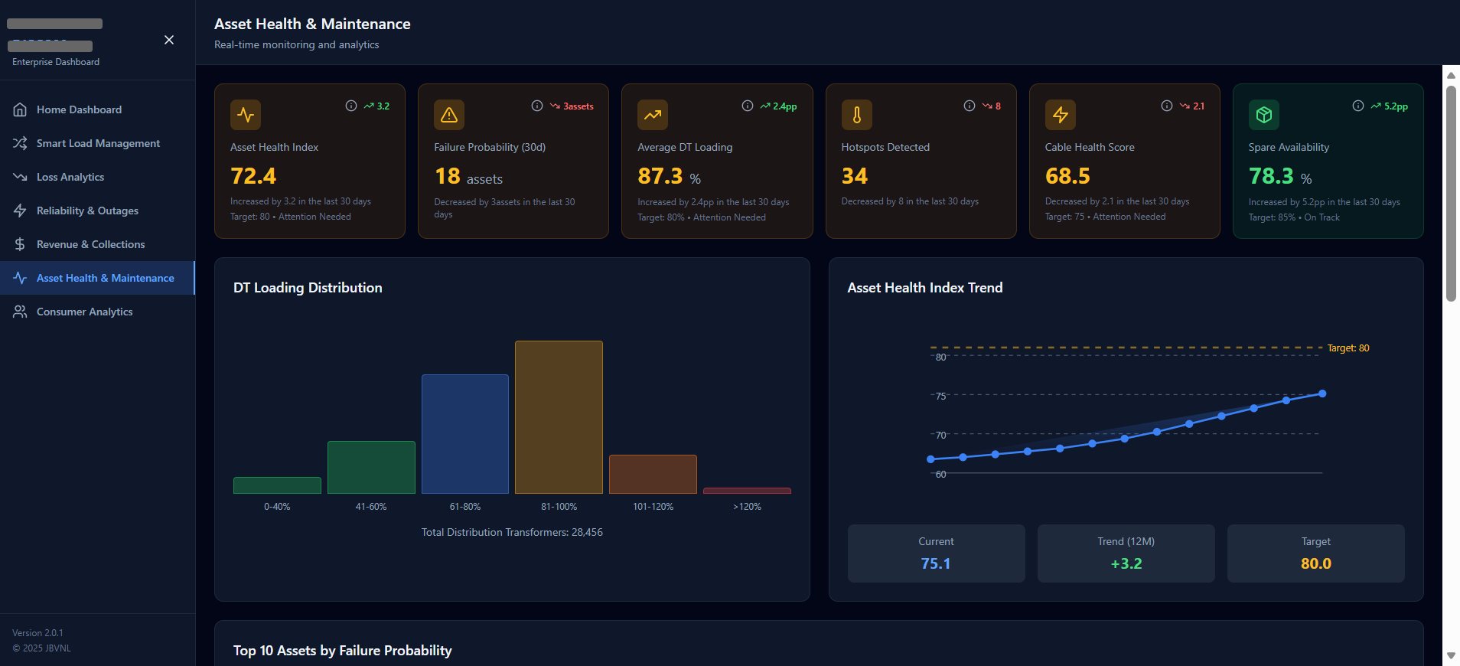
Provides a real-time view of asset health, failure probability, transformer loading, hotspots, cable condition, and spare availability. It combines health-index trends, anomaly detection, predictive ageing, and risk-based asset rankings to support proactive maintenance and improve reliability.
2. Critical Asset Risk & Maintenance Dashboard
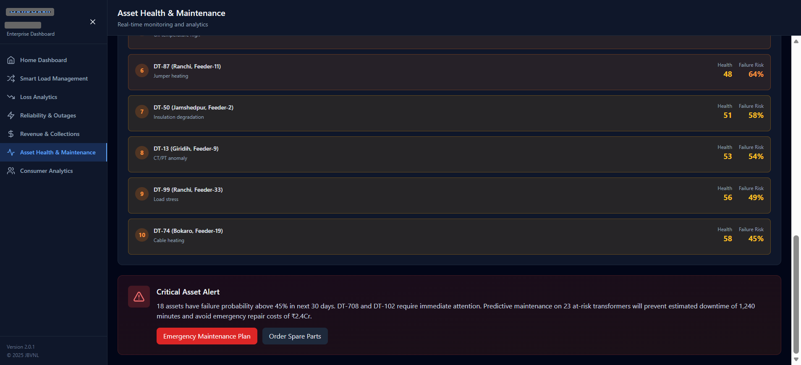
Ranks high-risk assets using health scores, failure probability, and detected failure causes such as overheating or insulation degradation. It generates critical alerts and supports immediate actions—including emergency maintenance planning and spare-parts procurement—to reduce downtime and operational risk.
3. Enterprise Performance Overview Dashboard
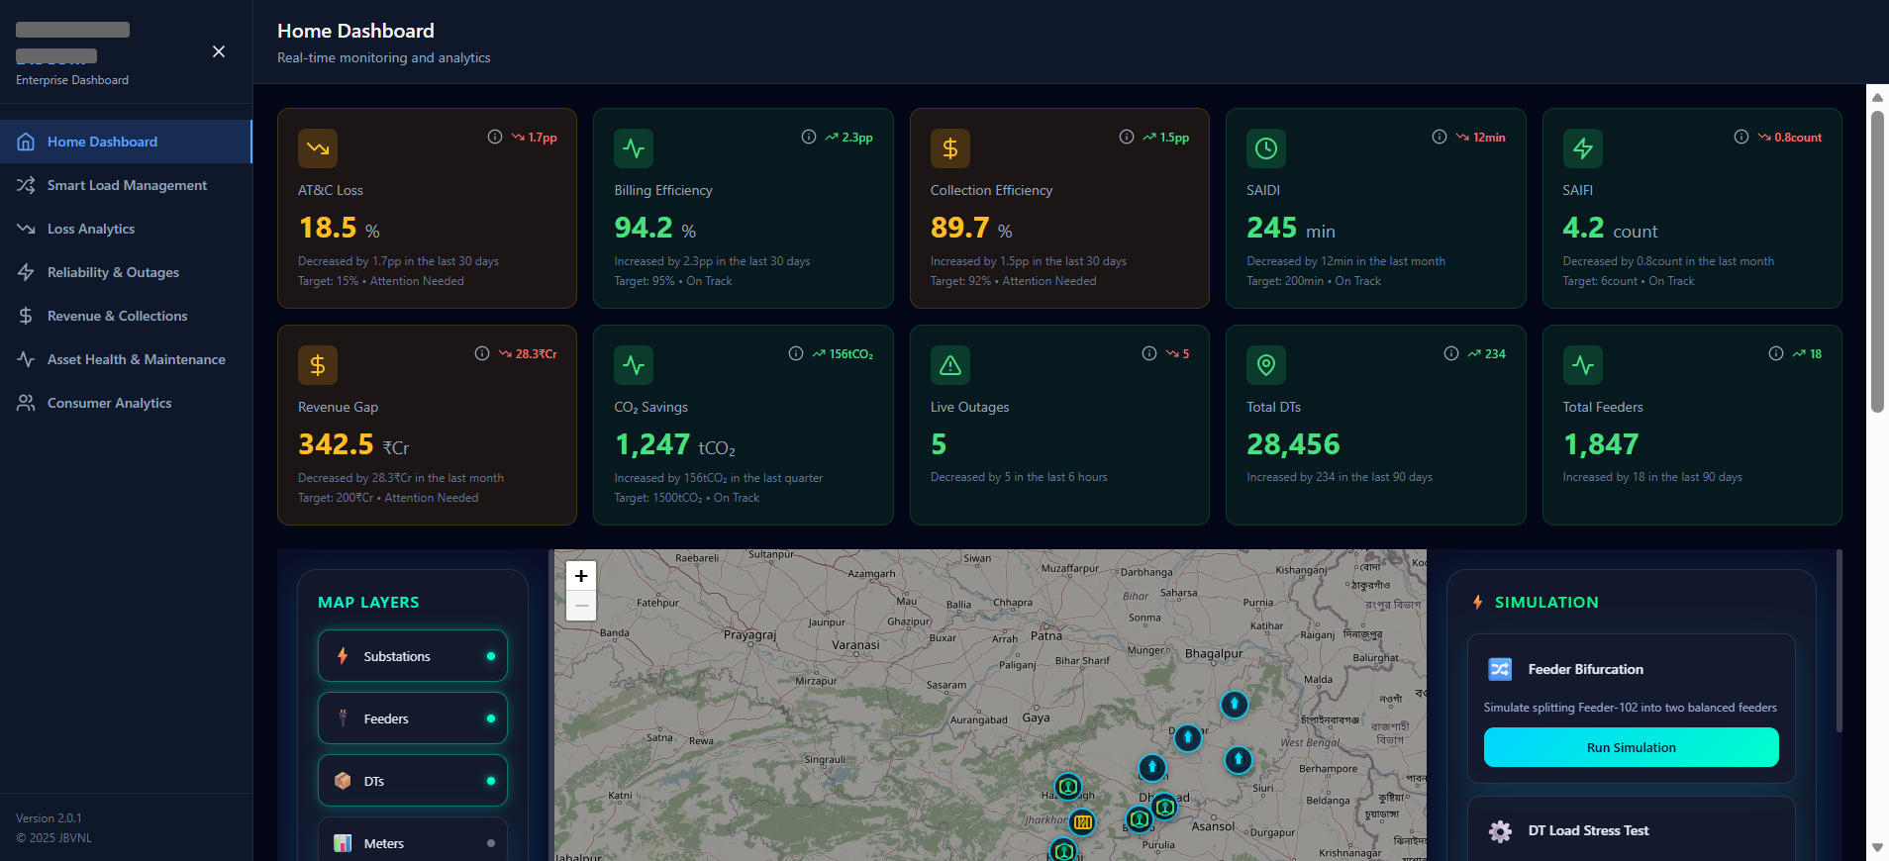
Provides an executive view of operational, financial, and reliability KPIs, including AT&C loss, billing and collection efficiency, outages, SAIDI/SAIFI, revenue gap, and CO₂ savings. The geospatial network map and simulation tools support asset monitoring, feeder reconfiguration, load assessment, and faster operational decision-making.
4.Live Alerts & AI-Powered Insights Dashboard
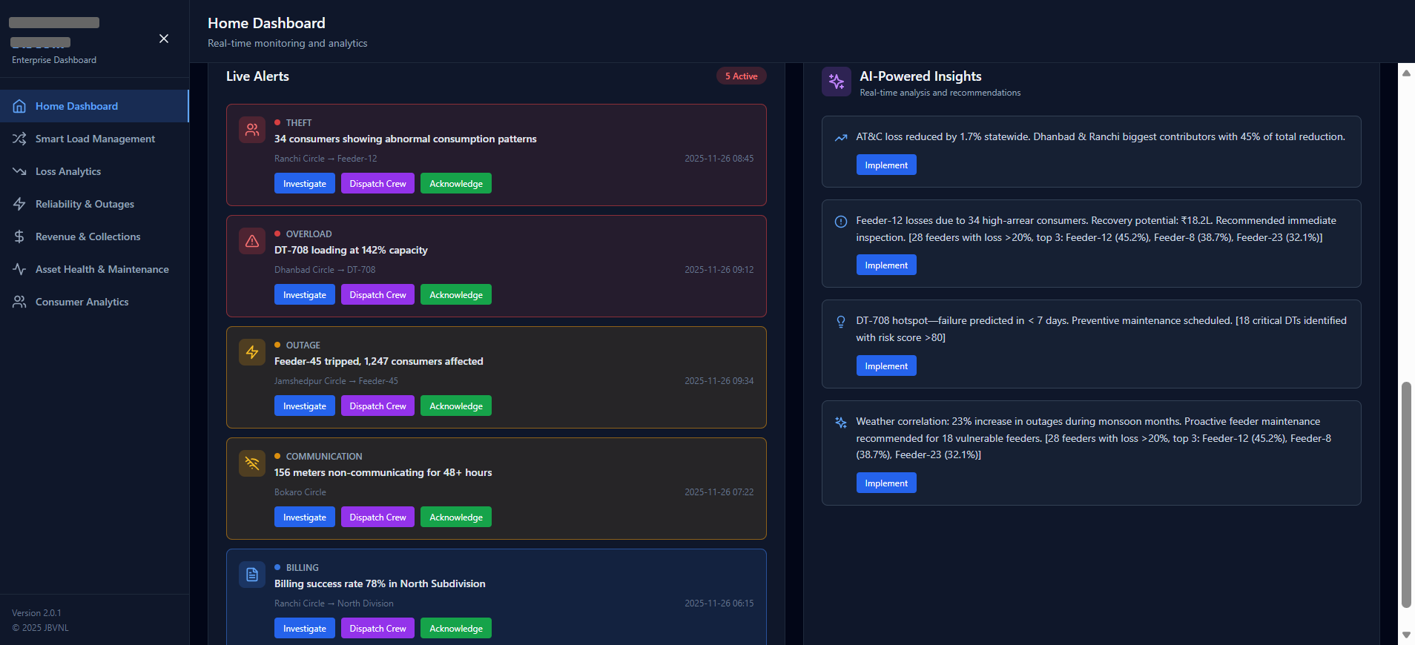
Consolidates real-time alerts for theft, overloads, outages, communication failures, and billing issues, with options to investigate, dispatch crews, or acknowledge incidents. AI-generated insights identify root causes, predict emerging risks, quantify operational impact, and recommend prioritized corrective actions.

7. System Integration
The proposed solution integrates with TPCL’s existing IT/OT environment through AVEVA and S!aP ML & AI Analytics, without replacing existing TPCL systems.

7.1 Primary Integration — Grid Data Hub
TPCL’s Grid Data Hub (GDH) will be the primary data-integration point. It will provide operational and enterprise data through APIs, SFTP/FTP, messaging queues, ODBC, or approved file-based interfaces. The solution will be hosted on the same VNet as GDH, as required by RFQ Section 3.6.1.

7.2 Source-System Integrations
System | Integration Purpose | Proposed Method
GDH | Unified historical and real-time asset data | APIs, ODBC, files, or messaging queues
SAP | Maintenance, inventory, project, financial, and customer data | Primarily via GDH; CSV where required
GIS | Asset location and network topology | Via GDH or CSV
ADMS | Network operations and switching states | Via GDH or approved database connectivity
SCADA | Real-time operational telemetry | Via GDH or approved database connectivity
CYME | Load-flow and network-planning analysis | Via GDH
MDM | Meter readings, events, and consumption data | Via GDH or CSV
The final interface method and field mappings for each system will be confirmed during Blueprinting.

7.3 Integration Standards
The integration will support:
- XML, JSON, and CSV data formats.
- REST, SOAP, ODBC, SFTP/FTP, and messaging protocols.
- Real-time, near-real-time, and batch data refresh.
- Secure and documented APIs for future integration.
- Schema validation, data-quality checks, error handling, and interface monitoring.
- Secure bi-directional data exchange between AVEVA and S!aP ML & AI Analytics.

7.4 Data Volumetric Profile
As specified in RFQ Section 3.7, the estimated data volume is:
Data Load | Estimated Volume
Initial load | Approximately 20,000 GB
Daily incremental load | Approximately 15 GB/day
The detailed system-wise volume, retention requirements, refresh frequency, and migration scope will be validated during Blueprinting.

8. Cybersecurity & Data Governance
Astrikos will ensure that all components of the solution comply with TPCL's cybersecurity standards, applicable legal and regulatory requirements (including CERT-In and CEA guidelines), and industry best practices (ISO/IEC 27001), as mandated in RFQ Sections 3.6.3, 3.6.6, and 4.

8.1 Security Architecture & Access Control
- Defence-in-depth design, including secure network segmentation and least-privilege access.
- Role-Based Access Control (RBAC) and Attribute-Based Access Control (ABAC), integrated with TPCL's central directory and Multi-Factor Authentication (MFA).

8.2 Data Protection
- Encryption of data at rest and in transit using approved cryptographic standards (AES-256, TLS 1.2/1.3).
- Data masking and row/column-level security for sensitive data.
- Data retained for one year and securely archived or deleted thereafter as per compliance requirements — exact retention schedule to be confirmed during the detailed requirement study / design phase in line with TPCL policy.

8.3 Monitoring & Compliance
- Comprehensive logging integrated with TPCL's SIEM solution (Microsoft Sentinel).
- Complete audit trails for all user activities and data changes.
- Periodic security assessments, vulnerability scanning, and timely patching.

8.4 Incident Response & Continuity
- A documented incident-response plan, including reporting and escalation procedures.
- Backup and disaster-recovery strategies meeting the defined RTO (≤ 1 hour) and RPO (≤ 15 minutes) requirements.

8.5 VAPT Requirements
- Penetration and vulnerability assessment testing performed by CERT-IN certified auditors during SAT and throughout the Operations & Maintenance period.
- A VAPT audit certificate produced before Go-Live and annually during the AMC period.

8.6 Security & Compliance Deliverables
Deliverable | Description
Security Architecture Document | Documents the full security architecture and access-control matrix.
Data Protection & Encryption Plan | Documents encryption standards, key management, and data-masking approach.
Vulnerability & Patch Compliance Reports | Produced yearly, covering vulnerability scanning and patch status.
Incident Response & Audit Trail Documentation | Documents the incident-response plan and maintains the audit-trail record.
VAPT Audit Certificate | Issued by a CERT-IN certified auditor, produced before Go-Live and annually during AMC.

8.7 Data Governance Principles
- All data storage and processing hosted within India, ensuring compliance with national data-sovereignty requirements.
- Data Ownership: all data generated through the use of the system always remains the exclusive property of TPCL, including upon contract expiry or termination; Astrikos has no rights over the data beyond operational use for service delivery.
- Compliance with ISO/IEC 27001 (Information Security Management) and MeitY Cloud Guidelines.
- All resources (onsite and offshore) engaged by Astrikos will comply with TPCL's data-leakage guidelines; no data from TPCL's environment will be copied, transferred, or taken out of the environment under any circumstances, and all laptops/devices will be installed with TPCL-provided information-security (InfoSec) software, as required under RFQ Section 5.

9. Implementation Approach
Month | Phase | Key Activities | Deliverables and Sign-Off
1 | Discovery and Blueprinting | Confirm APM/AIP use cases, data sources, integration requirements, asset hierarchy, KPIs, security controls, reporting requirements, and acceptance criteria | BRD, Solution Architecture Document, Detailed Design Document, integration catalogue, data-mapping plan, project schedule, and blueprint sign-off
2 | Integration and Foundation Build | Configure AVEVA and S!aP ML & AI Analytics; establish GDH and approved source-system connections; configure asset hierarchy, data validation, security, and analytical foundations | Configured development environment, source integrations, asset-data model, data-quality rules, security design, and integration test results
3 | APM Use-Case Implementation | Implement AHI, ACI/ARI, condition monitoring, anomaly detection, predictive ageing, RUL, FMECA, and reliability-centred maintenance use cases | Configured APM models, dashboards, reports, system-integration testing, APM UAT, and Milestone 2 sign-off
4 | AIP Use-Case Implementation | Implement investment-value scoring, CAPEX/OPEX optimization, scenario modelling, asset lifecycle planning, resource allocation, and tariff/ARR impact analysis | Configured AIP models, scenarios, dashboards, reports, and preliminary business-validation results
5 | AIP UAT and Go-Live Readiness | Complete end-to-end AIP UAT, performance testing, security testing, VAPT, user training, data validation, defect resolution, and production-readiness assessment | AIP UAT sign-off, training completion, VAPT clearance, production deployment plan, operating procedures, and Milestone 3 sign-off
6 | Go-Live and Hypercare | Deploy the solution to production, monitor integrations and analytical performance, resolve priority issues, support users, and complete knowledge transfer | Go-Live sign-off, issue-resolution reports, performance reports, knowledge-transfer records, and initial Hypercare report

10. Testing & Acceptance
The RFQ's Inspection Test Plan (Annexure VIII) is marked "NA," consistent with this being a software/SaaS engagement rather than a manufactured-goods supply; accordingly, no factory inspection or Factory Acceptance Test (FAT) applies. Astrikos' testing approach instead centres on System Integration Testing (SIT), Security Acceptance Testing (SAT), and User Acceptance Testing (UAT), consistent with the RFQ's explicit references to UAT (Scope of Work) and SAT (VAPT requirement, Section 3.6.3(f)).

10.1 Testing Stages
Stage | Scope | Owner / Participants
System Integration Testing (SIT) | Validates data flow and functional correctness across S!aP Connect ↔ Grid Data Hub ↔ AVEVA APM ↔ S!aP Datalake/ML & AI Central/BPM/Viz, including all documented API/file/messaging-queue integrations. | Astrikos delivery & QA team
Security Acceptance Testing (SAT) | Penetration and vulnerability assessment testing performed by CERT-IN certified auditors, per RFQ Section 3.6.3(f); VAPT audit certificate produced before Go-Live. | CERT-IN certified auditor (third-party) + Astrikos security team
User Acceptance Testing (UAT) | End-to-end UAT of APM use cases (Milestone 2) and AIP use cases (Milestone 3), against acceptance criteria agreed in the BRD, including customization and dashboarding. | TPCL business/technical users + Astrikos delivery team
Hypercare Validation | Post-go-live monitoring, issue-resolution tracking, and performance-monitoring reports culminating in formal hypercare sign-off (Milestone 4). | Astrikos managed-services team + TPCL

10.2 Acceptance Criteria
- UAT sign-off is tied to the functionalities identified during the discovery/Blueprinting phase and documented in the BRD, and to satisfaction of the SLA performance targets defined in RFQ Section 7 (login ≤ 5s, dashboard load ≤ 10s, asset search ≤ 5s, standard report ≤ 60s, API response ≤ 3s).
- SAT sign-off is tied to a clean (or risk-accepted, per TPCL policy) VAPT report from a CERT-IN certified auditor.
- Hypercare sign-off is tied to stabilization of the production environment with no outstanding Severity 1/2 incidents, per the Incident Management SLA defined in Section 16 of this proposal.

11. Training & Knowledge Transfer
Per RFQ Section 3.6.8 (Support & Maintenance), Astrikos will provide training and knowledge transfer to TPCL members as part of the implementation and ongoing managed-services engagement.

11.1 Training Tracks
Audience | Training Focus | Format
End Users (Field Engineers, Asset Managers) | AHI/ACI/ARI dashboards, maintenance-task workflows, condition-monitoring alerts | Instructor-led + user manuals
Planning & Regulatory Teams | AIP dashboards, scenario modelling, investment portfolio register, regulatory reporting | Instructor-led + user manuals
System Administrators | RBAC/ABAC configuration, threshold/rule configuration, integration monitoring, backup/DR procedures | Hands-on administrator training + admin manuals
Super Users / Power Users | Advanced configuration of health-scoring weights, risk thresholds, and RCM intervals under Glass Box governance | Hands-on workshops

12. Deliverables
The following table consolidates all deliverables committed under this proposal, directly traceable to RFQ Sections 3.1, 6, and 8.
- Blueprinting: BRD, solution architecture, detailed design, and requirements.
- Configuration: AVEVA APM and S!aP ML & AI Analytics configuration.
- APM: Implementation, dashboards, UAT, and sign-off.
- AIP: Implementation, dashboards, UAT, and sign-off.
- Documentation: API, database, configuration, security, and user manuals.
- Before Go-Live: Security assessment and CERT-In VAPT certification.
- Training and Hypercare: Training, knowledge transfer, monitoring, issue resolution, and sign-off.
Managed Services: L1/L2/L3 support, SLA reporting, patching, and change requests for 60 months.

13. Assumptions, Dependencies, Client Responsibilities and Exclusions

13.1 Assumptions
- The Grid Data Hub (GDH) is available, operational, and able to export the required data via REST/RESTful APIs, ODBC, file-based ingestion, or messaging queues, as described in the RFQ.
- TPCL will provide underlying cloud infrastructure/subscription (or access to provision within TPCL's existing cloud environment) on the same VNet as the GDH for hosting the APM/AIP SaaS solution.
- The list of source systems requiring direct (non-GDH) integration, and their exact field-level mappings, will be confirmed during the Blueprinting phase and documented in the BRD.
- TPCL will make available Active Directory/SSO and SIEM (Microsoft Sentinel) integration endpoints for RBAC/ABAC/MFA and security-log integration.
- TPCL will provide timely access to subject-matter experts, historical asset/maintenance/financial data, and decision-makers for design workshops, BRD sign-off, and UAT.
- The exact number of concurrent users, specific target enterprise NMS/ITSM systems (if any) for additional integration, and detailed non-GDH data-mapping specifications are to be confirmed during the detailed requirement study / design phase.
- Miscellaneous reports beyond the out-of-the-box dashboard suite will be discovered and scoped during the Blueprinting phase, per RFQ Section 3.5.

13.2 Dependencies
- GDH availability and data quality
- Cloud infrastructure on GDH VNet
- Access to SAP, ADMS, GIS, SCADA, CYME and MDM
- Active Directory, SSO and SIEM endpoints
- Historical data for AI/ML training
- Field devices and OT connectivity

13.3 Client Responsibilities
- Provide timely, accurate, and complete source data via the Grid Data Hub and any directly integrated systems.
- Nominate empowered business and technical stakeholders for BRD workshops, design reviews, UAT, and Decision Register sign-offs.
- Provision and maintain the underlying cloud infrastructure/subscription (or grant Astrikos access to provision within TPCL's environment) on the GDH VNet.
- Provide Active Directory/SSO and SIEM integration access for security architecture implementation.
- Ensure availability of subject-matter experts for validation of AHI/ACI/ARI scoring logic, RCM intervals, and AIP investment-valuation weights specific to TPCL's operational context.
- Fulfil obligations under RFQ Section 5 relating to onsite workspace, access, and environment provisioning for Astrikos' onsite resources.

13.4 Exclusions
- Supply, installation, and commissioning of physical field devices, sensors, RTUs, FRTUs, RMUs, meters, or any OT hardware — these remain existing TPCL infrastructure or third-party OEM scope.
- Development, operation, or licensing of the Grid Data Hub (GDH) platform itself — the GDH remains a TPCL-owned indigenous application.
- Civil, electrical, or network cabling works at any TPCL site.
- Licensing or operation of third-party enterprise systems named in the RFQ (SAP, ADMS, GIS, SCADA, CYME DIST, MDM, etc.) — Astrikos integrates with, but does not replace or re-license, these systems.
- Any requirement, specification, quantity, or timeline not stated in the RFQ and its annexures; such items, if identified, will be addressed through the RFQ's Change Management SLA (Section 16.4 of this proposal).

14. Key Differentiators / Why Astrikos
Astrikos combines the COTS-compliant AVEVA APM engine with configurable S!aP ML & AI Analytics to provide TPCL with an integrated, standards-aligned solution for APM and AIP. Key advantages include explainable “Glass Box” analytics for AHI, ACI, ARI, RUL and investment recommendations; configurable models without bespoke code changes; vendor-neutral integration with TPCL’s existing systems; and secure deployment within India on the GDH VNet, with TPCL retaining full ownership of its data.
As a single accountable implementation partner, Astrikos will manage Blueprinting, configuration, integration, analytics, dashboards, testing, Hypercare and 60-month managed services. The solution incorporates RBAC, ABAC, MFA, SIEM integration and CERT-In VAPT requirements, supported by relevant certifications, project references, financial credentials and qualified utility, AI/ML, analytics and cybersecurity resources.

Commercial
S!aP license and Platform Implementation Services
All Prices in USD | Qty | Unit Price in USD | Total Price in USD | Remarks
S!aP enterprise platform license, including the modules listed below, product updates, standard maintenance, and subscription rights
S!aP Konnect — data-source connectivity, integration configuration, API/connectors, and scheduled data exchange
S!aP Datalake — centralized data ingestion, storage, cataloguing, processing, and access capabilities
S!aP BPM — workflow design, business-process automation, approvals, task routing, and process monitoring
S!aP ML & AI Central — management of machine-learning and AI models, experiments, deployment, and monitoring
S!aP Viz — dashboards, reports, charts, filters, drill-downs, and data-visualization capabilities
S!aP Agentic — configuration and operation of AI agents, tools, knowledge sources, and governed agent workflows
S!ap Installation and Configuration Integration services:
•Platform Installation
•Platform Configuration
•Sub-System Integration
•Users and Security Configuration
•Dashboard building
Total in USD |  |  | $ 100,000.00

Item | BOQ Code | Description | Unit | Unit Price in INR | Total Year | Total Price in INR
1.1 | - | AVEVA Asset Performance Management Platform / APM Core | Annual subscription | 92,00,000.00 | 5
1.2 | - | Asset Strategy Library | Annual subscription |  | 5
1.3 | - | Enterprise Asset Information Model | Annual subscription |  | 5
1.4 | - | AVEVA Asset Information Management (AIM) Platform | Annual subscription |  | 5
1.1 | AAI-S!aP-LIC | S!aP enterprise platform license, including the modules listed below, product updates, standard maintenance, and subscription rights | Annual subscription |  | 5
1.2 | AAI-S!aP-KON | S!aP Konnect — data-source connectivity, integration configuration, API/connectors, and scheduled data exchange | Module
1.3 | AAI-S!aP-DL | S!aP Datalake — centralized data ingestion, storage, cataloguing, processing, and access capabilities | Module
1.4 | AAI-S!aP-BPM | S!aP BPM — workflow design, business-process automation, approvals, task routing, and process monitoring | Module
1.5 | AAI-S!aP-AIC | S!aP ML & AI Central — management of machine-learning and AI models, experiments, deployment, and monitoring | Module
1.6 | AAI-S!aP-VIZ | S!aP Viz — dashboards, reports, charts, filters, drill-downs, and data-visualization capabilities | Module
1.7 | AAI-S!aP-AGT | S!aP Agentic — configuration and operation of AI agents, tools, knowledge sources, and governed agent workflows | Module
S!ap Installation and Configuration Integration services:
•Platform Installation
•Platform Configuration
•Sub-System Integration
•Users and Security Configuration
•Dashboard building

